Report
Mental Health of Pregnant Women During
COVID-19

Soukhya Madan Nayak
Kle Technological University
Belgavi, India
02fe22bcs148@kletech.ac.in

Prem V
Kle Technological University
Belgavi, India
02fe22bcs072@kletech.ac.in
Sharanamma Katti
Kle Technological University
Belgavi, India
02fe22bcs119@kletech.ac.in
Abhishek Angdi
Kle Technological University
Belgavi, India
02fe22bcs005@kletech.ac.in

Introduction to THE mental health of pregnant women during COVID-19
The COVID-19 pandemic has significantly impacted the global system, economics, and everyday life. Among the vulnerable populations affected, pregnant women have faced unique challenges that have had substantial implications for their mental health. The stress and uncertainty associated with the pandemic, combined with the physiological and physiological changes of pregnancy, have contributed to increased levels of anxiety, depression, and other mental health concerns among the group.

RELATED WORK
a) Impact of COVID-19 on maternal mental health
b) psychological impact of COVID-19 pandemic on pregnant women
c) Mental health outcomes of pregnant postpartum women during the COVID-19 pandemic-A systematic review and meta-analysis
d) The effect of COVID-19 on maternal mental health in the perinatal period: A qualitative study
e) Anxiety and depression among pregnant women during COVID-19 pandemic country survey

DATASET DESCRIPTION AND PREPROCESSING
The data set is fetched from the source
https://www.kaggle.com/datasets/yeganehbavafa/mental-health-in-the-pregnancy-during-the-covid-19
Has a total of 10772 rows, 16 columns 10 numerical attributes, and 6 categorical attributes.
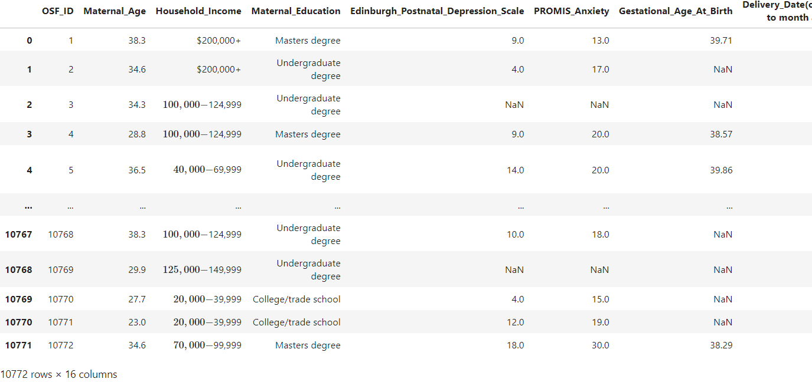

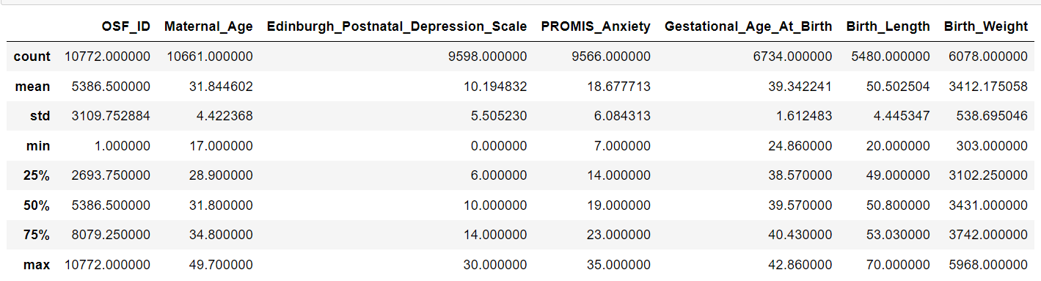

ATTRIBUTES
Maternal_Age: Maternal age (years) at
intake
  - Household_Income: What is the total household income, before taxes and deductions, of all the household members from all sources in 2019
  - Maternal_Education: Maternal education
1- Less than high school
2- diploma
3- High school diploma
4- College/trade school
5- Undergraduate degree
6- Master's degree
7- Doctoral Degree
  - EPDS: Edinburgh Postnatal Depression Scale (you can find the survey on the internet)
  - PROMIS_Anxiety: Score from 7 to 35 with higher scores indicating greater severity of anxiety.
  - GAbirth: Gestational age at birth (in weeks)
  - Delivery_Date: Delivery Date (Dates converted to month/year of birth)
  - Birth_Length: Birth length in cm
  - Birth_Weight: Birth weight in grams
  - Delivery_Mode: Vaginally or Caesarean-section (c-section)
  - NICU_stay: Was your infant admitted to the NICU?
  - Language: Survey language
  - Threaten_Life: How much do (did) you think your life is (was) in danger during the COVID-19 pandemic? (0-100)

  - Threaten_Baby_Danger: How much do (did) you think your unborn baby's life is (was) in danger at any time during the COVID-19 pandemic? (0-100)
  - Threaten_Baby_Harm: How much are you worried that exposure to the COVID-19 virus will harm your unborn baby? (0-100)

Data Distribution (do it for all the variables)
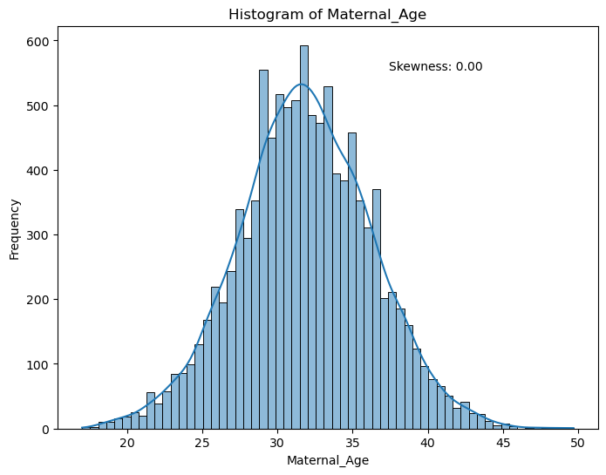
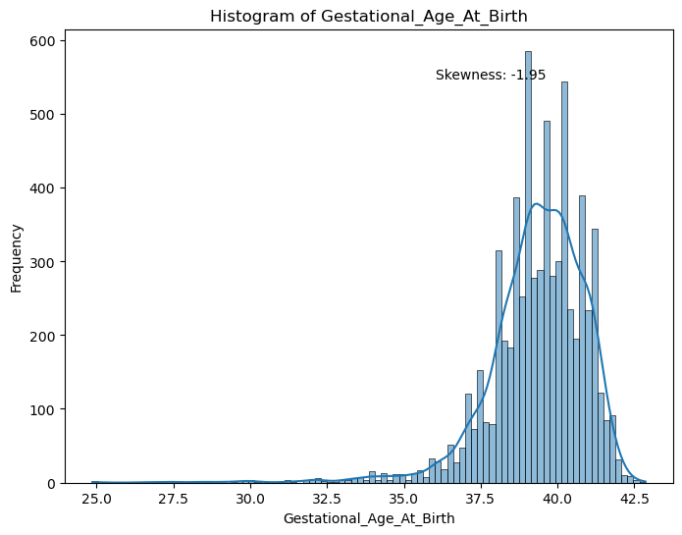
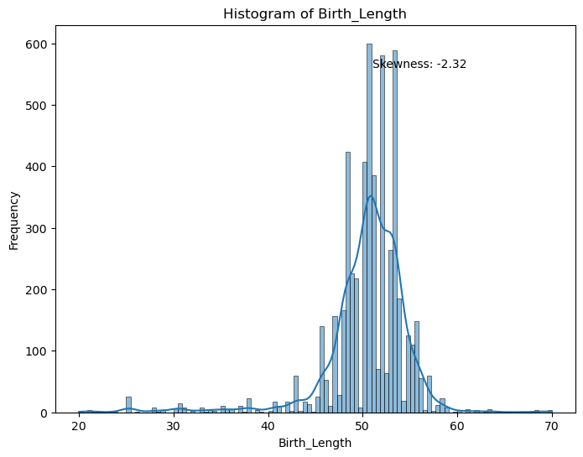
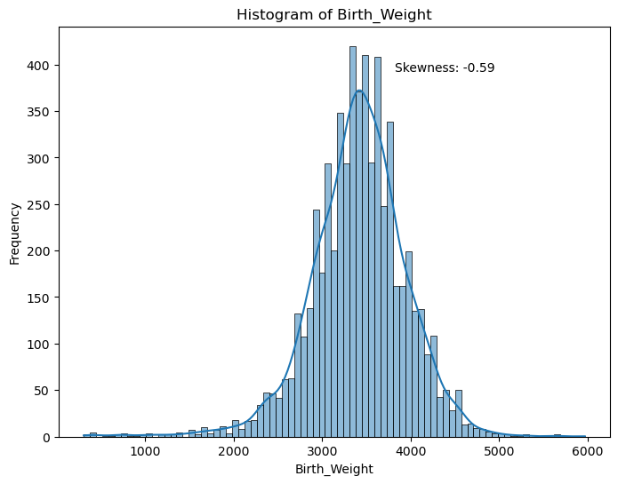

Handling Missing values
For numerical data, the skewness of each attribute needs to be checked, and then if the attribute is positively skewed null values must be substituted with mean, if negatively skewed null values must be substituted with median and for categorical data null values must be substituted with mode.
Maternal Education | 177
Household Income | 251
EPDS Score | 1174
Promise Anxiety | 1206
Gestational age at birth | 4038
Delivery date | 4039
Birth length | 5292
Birth weight | 4694
Delivery Mode | 5235
NICU Stay | 5238
Maternal Age | 111

Handling Outliers
After filling the null values check for the outliers for each attribute if there are more outliers then that particular column can be deleted. If there are outliers in little quantity and that attribute is essential for visualization then we need to go for a capping technique which is finding the upper and lower fence and substituting the values of the lower fence to the values that are less than the lower fence and substituting the values of the upper fence to the values that are less than an upper fence.

Standardization/Normalization/String Processing
Identify the applicable funding agency here. If none, delete this text box.
We have converted categorical data to numerical data for delivery mode-(1-vaginally 0 – c-section), maternal education (0-college trade school, 2-doctoral degree,3-less than high school diploma, 4-master degree, 5-undergraduate degree), and also, separated the column of delivery date as month and year.

Correlation Matrix
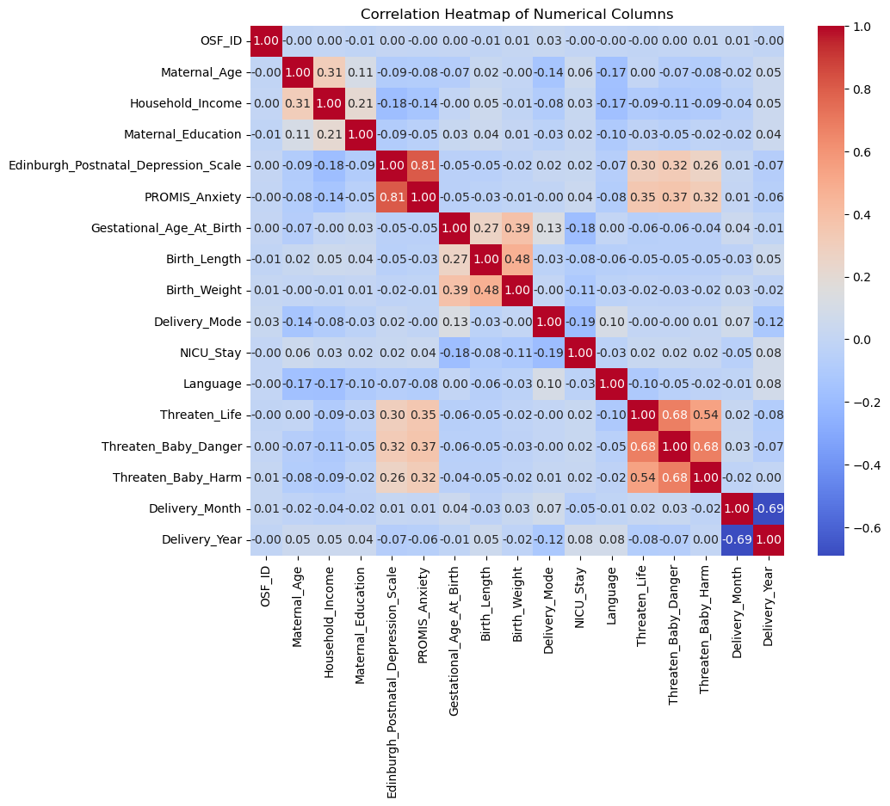
The correlation heatmap gives us a strong relation between 2 attribute values higher score with the darker block indicates the strongest correlation. This map is helpful for bivariate analysis.

Exploratory data analysis
Analyzing the data, cleaning the data finding hypotheses, and giving solutions for it.

Univariate Analysis

What is the highest household income?
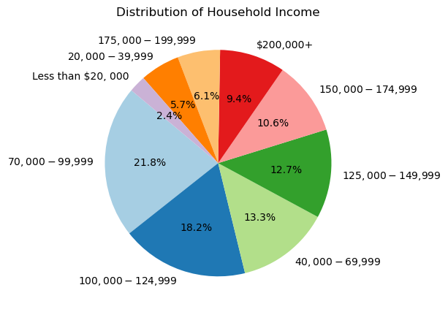
Maximum-70000 to 99999 and Minimum 20000 to 39999

2)What is the highest rate of maternal education?
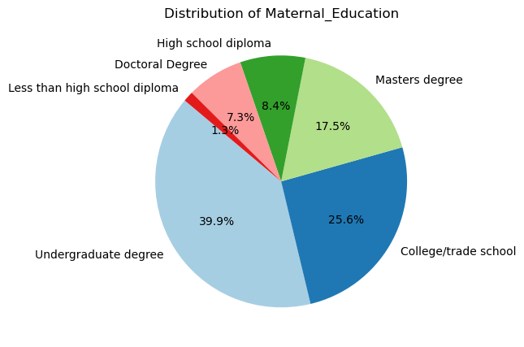
Most women received undergraduate degrees.

3)What is the highest EPS score?
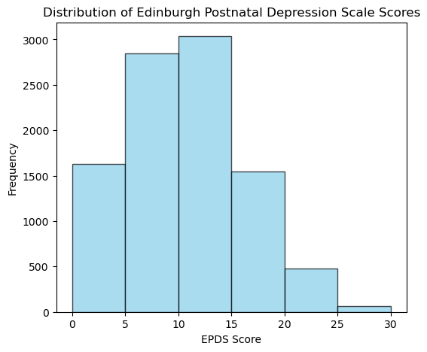
Highest score is between 10-15.

Bivariate Analysis
1)Does threatening life have any effect on threatening baby danger?
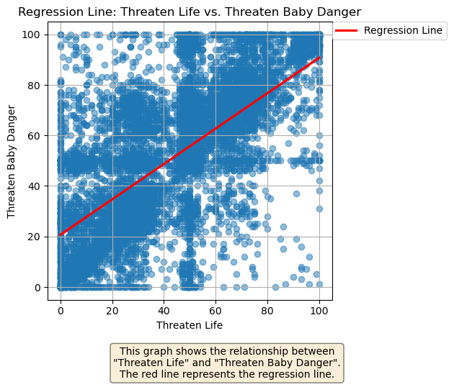
They are increasing in nature

2)How does maternal education and household income are related?
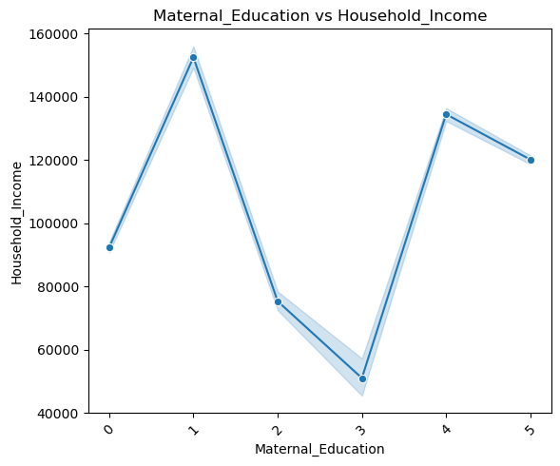
Highest educated women having high household income.

3)How is depression anxiety related?
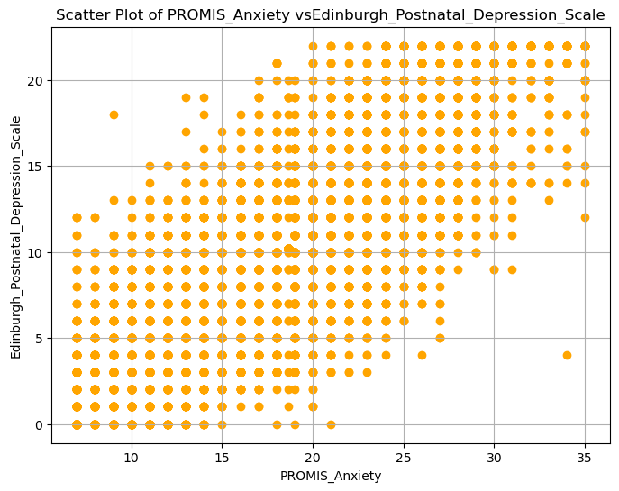
They are increasing in nature.

4)How are gestational age at birth and birth weight related?
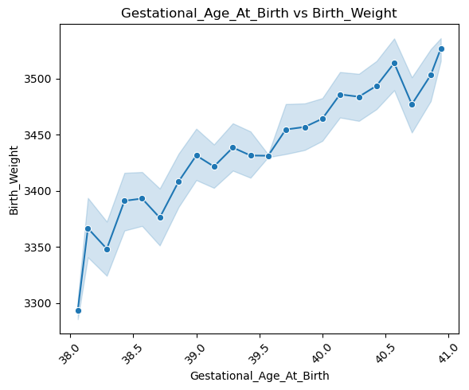
As the gestational age increases birth weight increases age lies between 38 to 42 weeks.

5) How are gestational age at birth and birth length related?
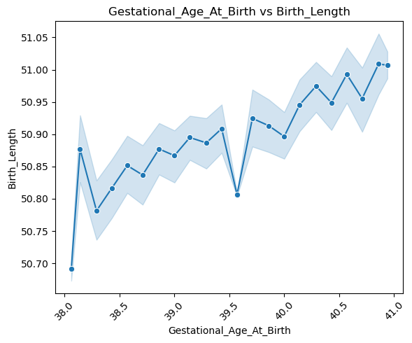
Both increases in nature’s average length are 49 to 50cm.

6)How do gestational age and delivery mode are related?
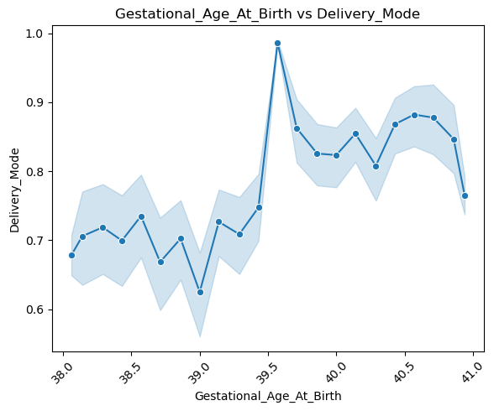
As the age increases mother delivers vaginally

7)How is depression related to the threat of baby harm?
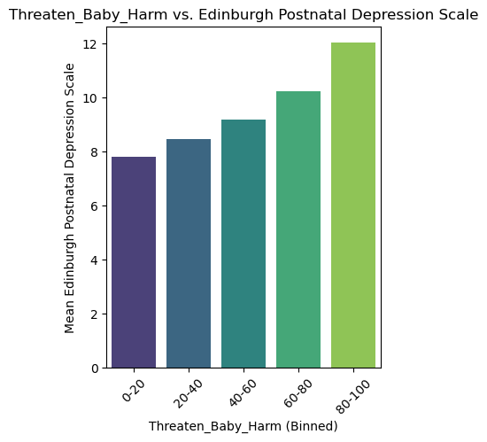
Increasing in nature.

8)How is depression related to the threat to life?
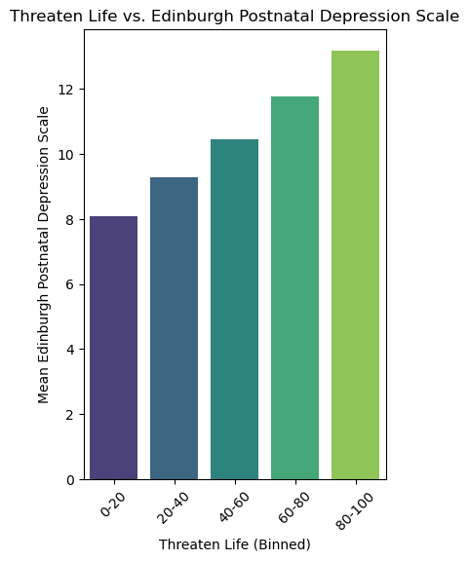
They are increasing in nature.

9)How is maternal age-related to the depression scale?
-
Depression is more common in younger women.

10)Does the frequency of threatened life incidents vary significantly across different months of the year?
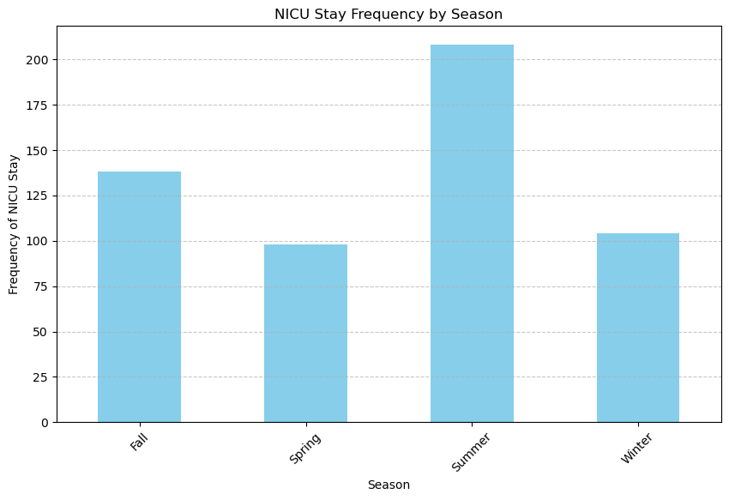
NICU stay is more in summer and less in winter.

C. Multivariate Analysis
1)What is the relationship between maternal education, household income, and depression scale?

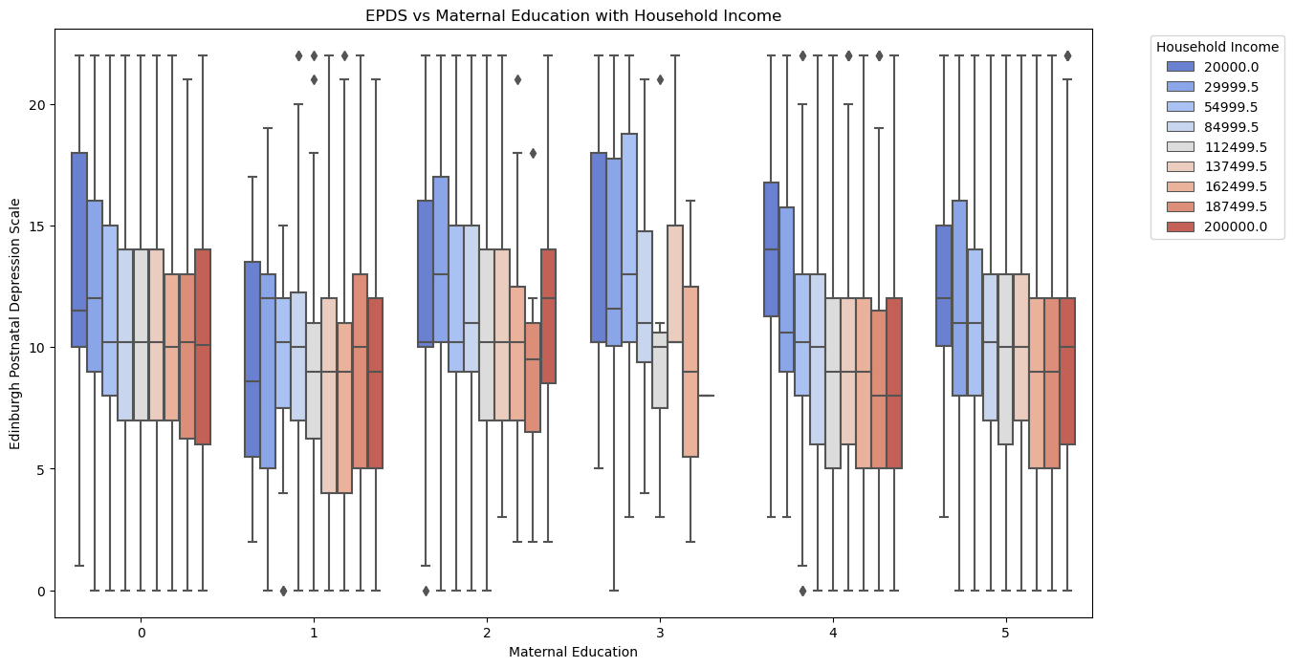
Depression more for ‘less than high school diploma’ less for ‘undergraduate degree’ household income is more for ‘doctoral degree’ less for ‘less than high school diploma’ From the above graph we can infer that lowest household income women with education level ‘less than high school diploma’ like;y to be more depressed.

2)How does birth weight and length impact depression scores?
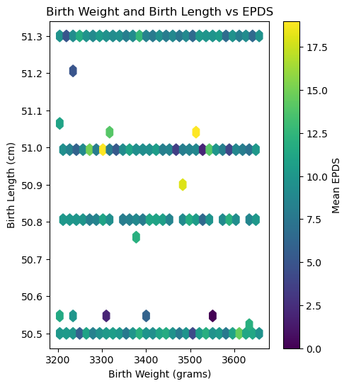
EPDS score is less than the baby’s normal weight and length of 3000g and 51cm.

3)How do mode of delivery and NICU stay influence EPDS scores?
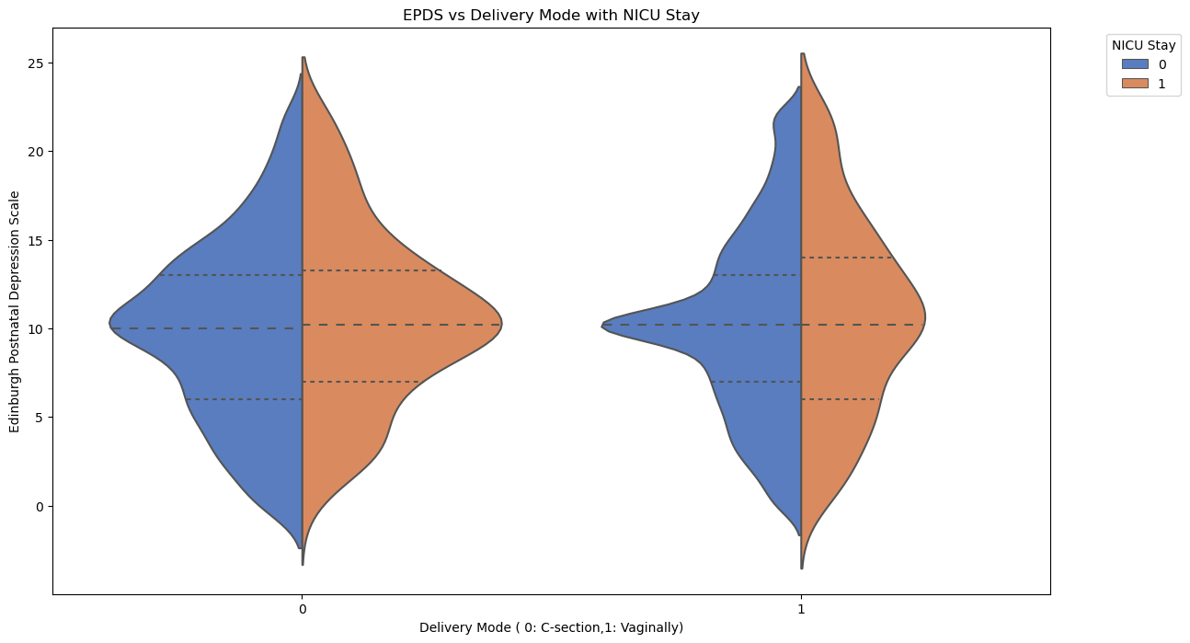
Slightly tendency for high EPDS scores among mothers whose babies stayed in NICU, especially for those who have delivered vaginally ends scores concentrated between 5 to 15

4)What is the correlation between EPDS scores, anxiety, and threat to life?
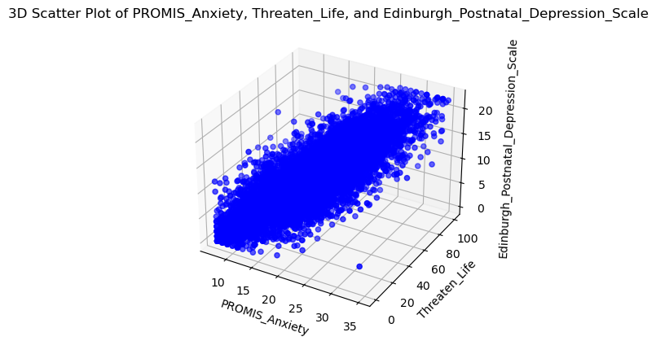
As their mother worries about her life due to covid-19 her anxiety increases and depression also increases.

v. CONCLUSION
Higher household income may be associated with better mental health, suggesting financial stability. Higher education levels may experience lower levels of depression and anxiety, indicating education could be a protective factor against mental health issues. The increased perceived threat to life and baby safety strongly correlated with anxiety and depression, highlighting the psychological toll of fear and uncertainty during a pandemic.

References
https://www.kaggle.com/datasets/yeganehbavafa/mental-health-in-the-pregnancy-during-the-covid-19
https://semaphoreci.medium.com/how-to-handle-imbalanced-data-for-machine-learning-in-python-b6d56c9a0489
https://medium.com/@liam.lim/data-analysis-project-1-exploratory-data-analysis-eda-with-python-3b0bd40332b1

